DATA VISUALIZATION DA

CSE 3050

**ZOHO ANALYTICS:**

**1) visualization techniques:**

In this tool we can make use of a variety of charts, widgets, pivot, summary and tabular views to create insightful reports and dashboards.

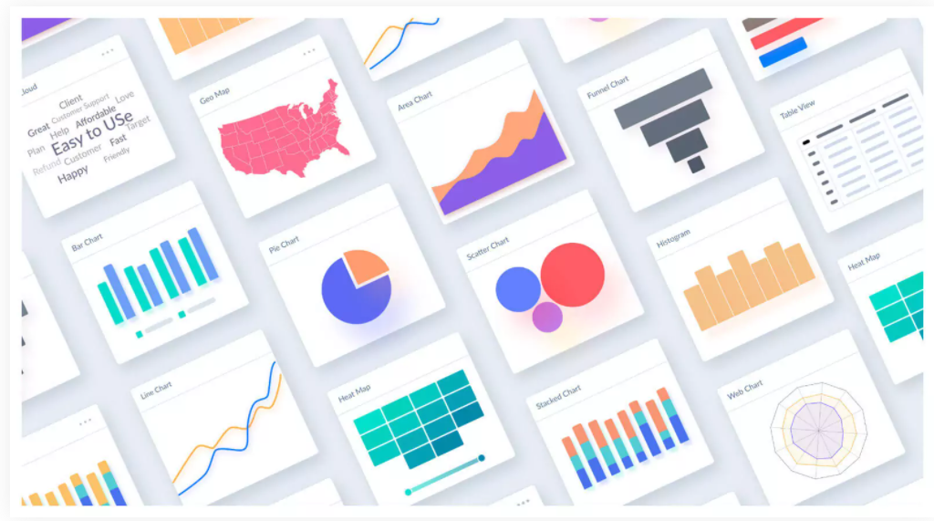

**Image based visualization:**

Plot location data spread over custom images boundaries, like basketball courts, city parking lots, roads etc. Include creative image visuals in your reports to enhance visual appeal & readability.

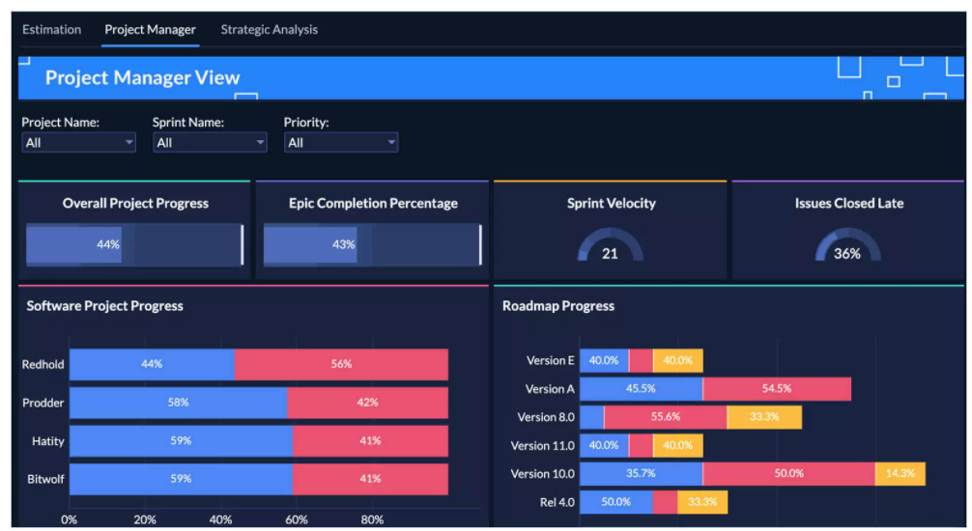

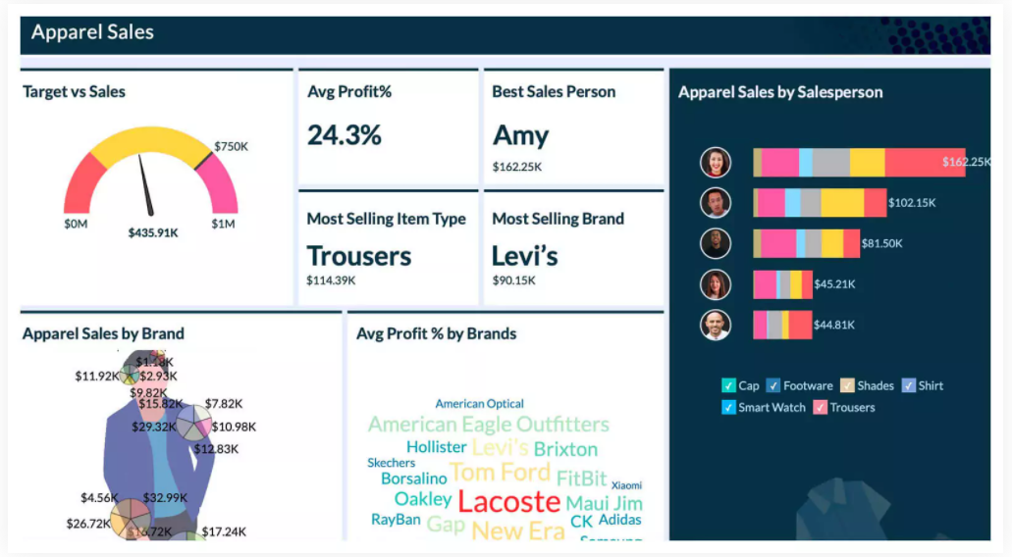

**2) interactive techniques**

This tool makes use a range of interactive options like view underlying data, drill downs, contextual filters, and many more, to perform ad-hoc exploratory analysis.

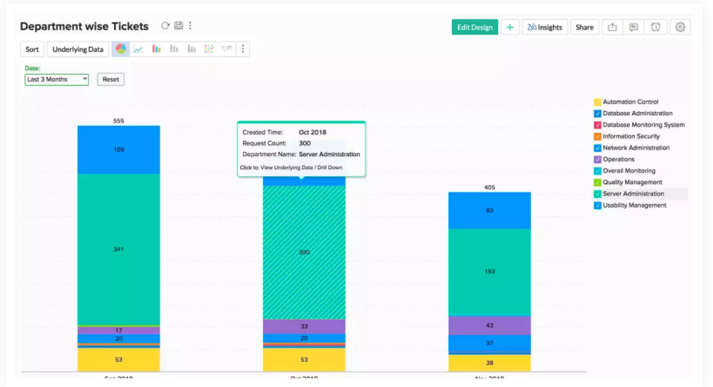

**GEO VISUALIZATION:**

This tool Analyses the given geographical data with interactive map charts. Compares and measures key metrics across countries, regions, states, counties, postal codes and even with latitudes and longitudes.

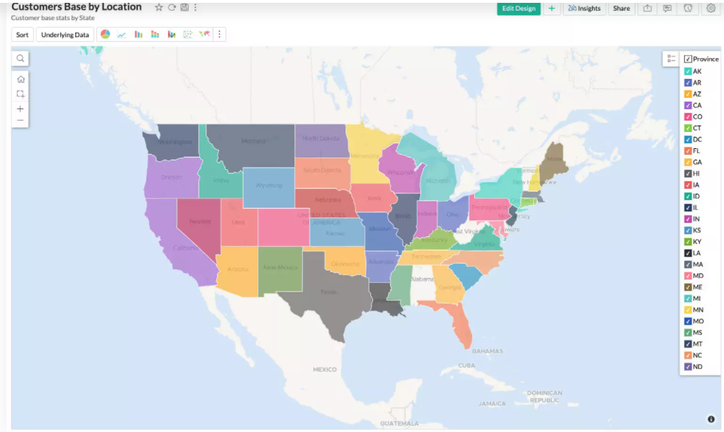

**ZIA:**

Zoho Analytics is augmented with AI capabilities through Zia, our AI-powered analytical assistant. Zia provides critical business insights in seconds through natural language processing capabilities via Ask Zia forconversation analytics, Zia Insights for automated insights, and more.Get contextual and actionable insights that go beyond visualizations, in the form of digestible narrations with zero interactions.

Engage in colloquial conversations with Ask Zia, and get relevant reports as answers. Learn more about Zia.

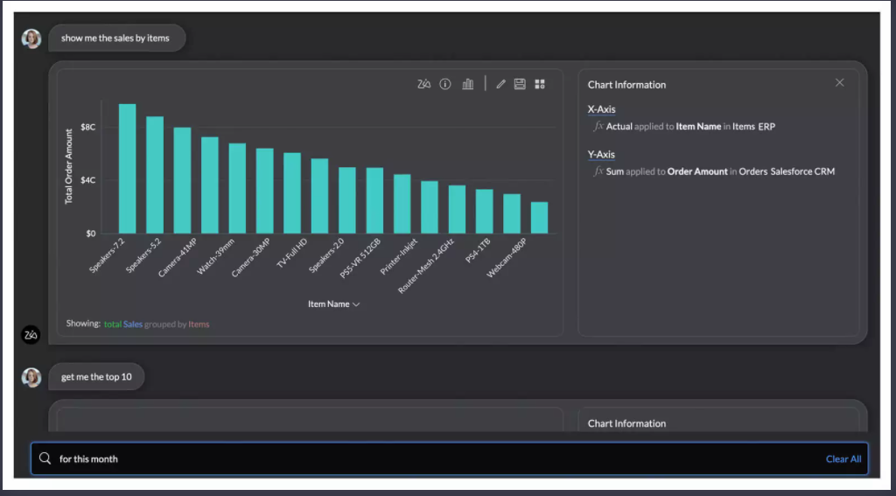

**3) data storage formats**

One can Upload data from spreadsheets & flat files like Microsoft Excel, CSV, HTML, JSON, XML, text files and more. Feed data from online storage services like Zoho Docs, Google Drive, Box, Dropbox & Microsoft OneDrive. Pull data from Web URL feeds.

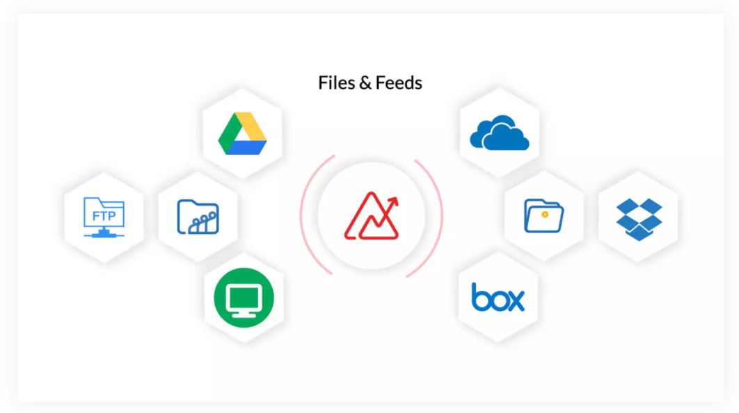

**4) statistical and Machine Learning techniques**

**Augmented Analytics**

Augment your analysis of data with technologies like artificial intelligence (AI), machine learning (ML), natural language processing and generation (NLP/G), and get quick insights from your data.

**Predictive analytics**

Apply custom forecast models, and forecast values of your business metrics. Predict upcoming trends.

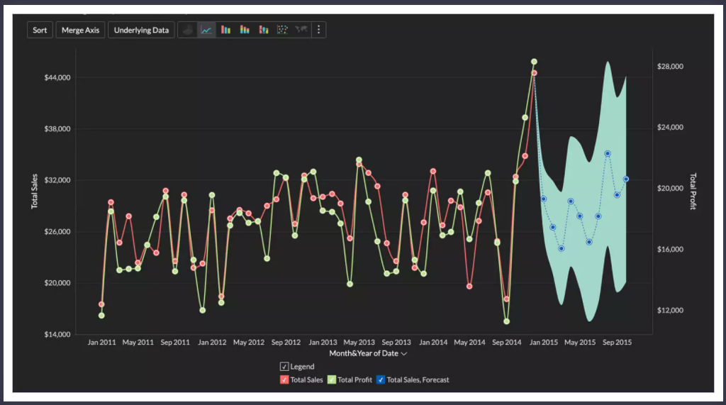

**Enrich data**

Enrich your data with ML/AI-powered transforms, such as sentiment analysis, keyword extraction, language detection, and more.

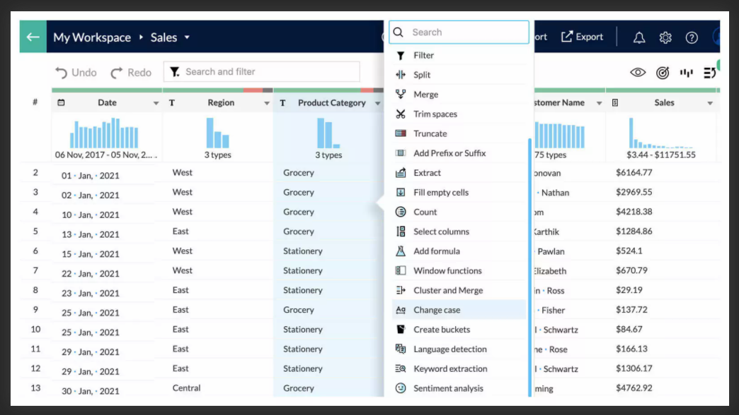

**5) visual idiom validation techniques**

Making use of this tool we one create a dashboard with their colleagues and share reports and notes and compare and decide the most suitable plan to achieve their goal

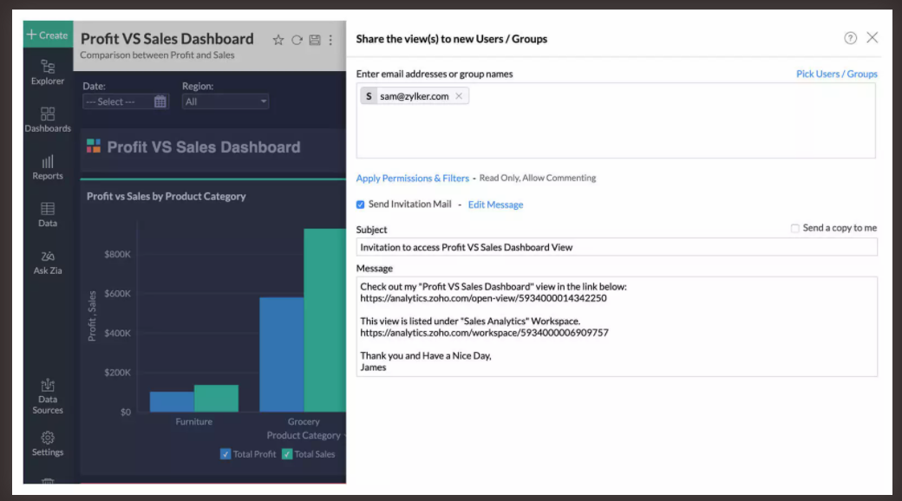

We can ask ZIA to compare the reports and projected profits by different reports regarding to their business, based on some pre defined parameters set by the admin, ZIA can help decide the more desirable choice

**6) data types**

**Auto Model**

Automatically identify data types. Get suggestions for joining datasets. Create custom data types to identify and fix invalid data.

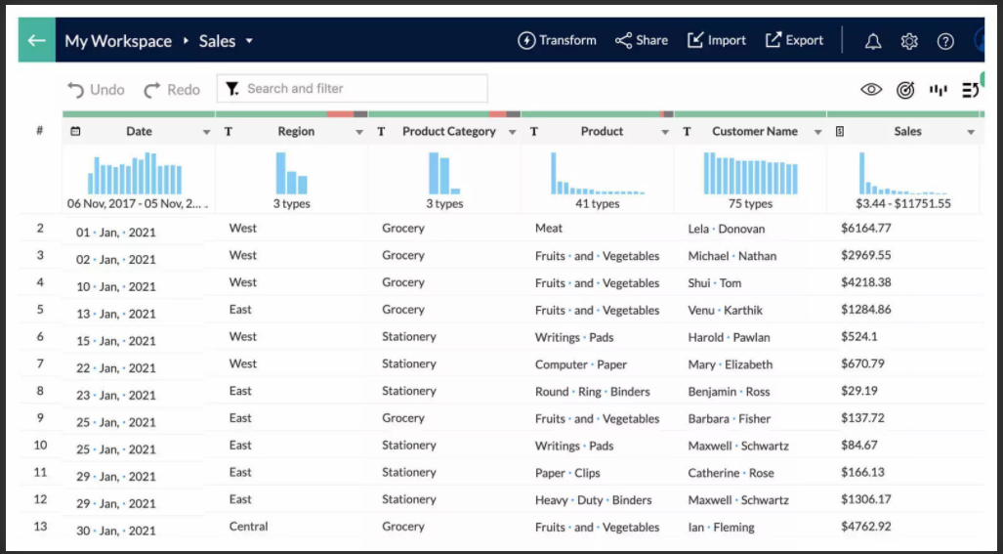

**7) dataset types**

**Catalog data**

Manage your datasets by categories, custom tags, data quality, data readiness, and more. Use our smart AI assistant Zia's search capabilities to perform system-wide metadata searches.

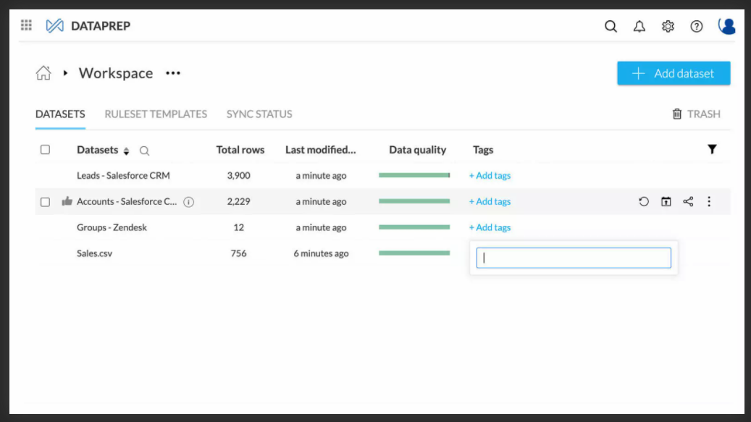

**8) Product Details:**

**deployable platforms**

**Cloud**

Access a full-fledged self-service BI & Analytics service hosted in Zoho cloud, with just a browser or mobile app. No upfront cost. Pay as you go in monthly subscriptions, no yearly lock-in.

**Onpremise**

Install Zoho Analytics behind your firewalls, in your own servers. Analyze your data in-house. Learn more about Zoho Analytics On-premise

**Public Cloud**

Deploy Zoho Analytics on public cloud of your choice. Like AWS, Google Cloud, or Microsoft Azure.

**Embedded**

Offer a full-fledged analytics app in your brand name. Either as a standalone analytics portal, or embedded within your own app. White label versions available in both cloud and onpremise.

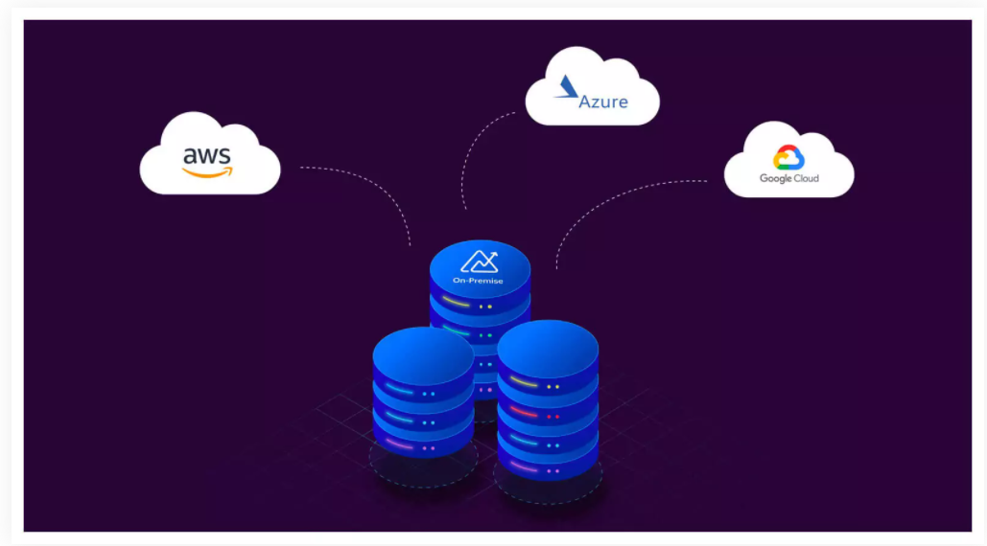

**free/commercial**

The pricing plans start at $25 per month and range up to $495 per month. You also get a 15-day free trial to check out the product.

**i Space requirement**

If you subscribe for a Professional edition and purchase 2 user licenses you will get a total storage space of 10 GB + 20 MB (10 MB for each user). You can purchase additional data storage and expand the storage limit to a maximum of 5 GB (This storage is independent of the user license purchase).

The storage limit per user for each plan is as follows: Free - 5 GB. Standard - 50 GB. Premium - 100 GB.